| **Job Sheet** |
| --- |

| **Module** | **:** | IoT Fundamentals | **Module Code** | **:** | EC33105FP | |
| --- | --- | --- | --- | --- | --- | --- |
|  |  |  |  |  |  | |
| **Job No** | **:** | 6 | **Duration** | **:** | F/T: | 3 hours |
|  |  |  |  |  | P/T: |  |

| **Job Title** | **:** | Integrate Sensor and Output |
| --- | --- | --- |
|  |  |  |
| **Objectives** | **:** | 1. Prepare RPi and Upswift 2. Connect Ultrasonic and LED 3. Execute program to get distance data and LED feedback |

**Tools, Equipment and Materials**

| PC |
| --- |
| RPi with microSD |
| RPi Power Adaptor  HC-SR04+ x 1  1 kohm x 3  220 ohm x 2  LEDs(red and green) x 2  Breadboard  4G WiFi Router |
|  |

**Number of Tasks to Complete**: 4

**Part A: Prepare RPi and Upswift (0.5 hour)**

Before performing any hardware configurations, we need to ensure that the RPi is accessible remotely.

YOU MUST HAVE COMPLETED JOB 1 BEFORE DOING THIS

**Task 1 – Prepare RPi and UpSwift**

Perform the following steps to setup RPi:

1. Connect only the power adaptor to RPi.
2. Turn on the power
3. Go to <https://dashboard.upswift.io/dashboard/> and login. The device would be **offline**.

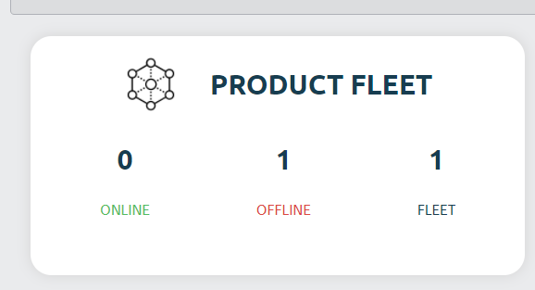

1. Wait for a while and refresh the web page by clicking . Device should appear online after 1 - 2 mins.

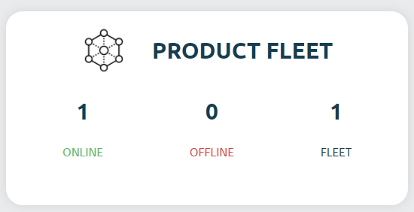

1. On the left side of your menu, click on the **Control** option under Control center.

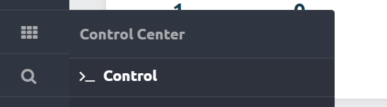

1. On the page center, select your device and click open session.

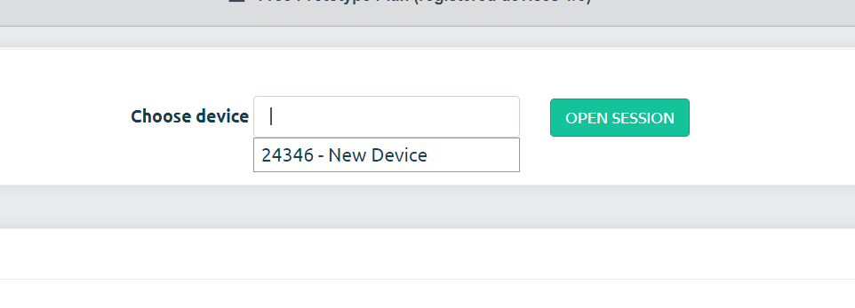

1. For the prompt, click **Open Remote Control.**

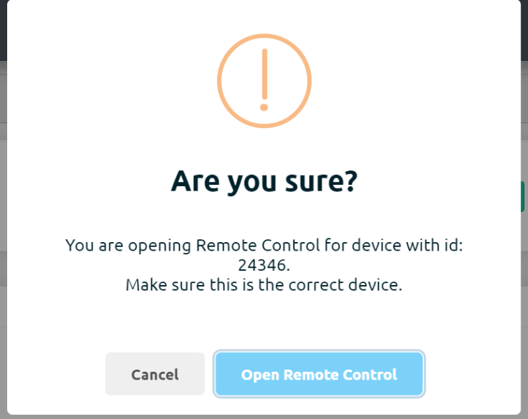

1. You will be shown a secret key. Click on **Copy to clipboard** button

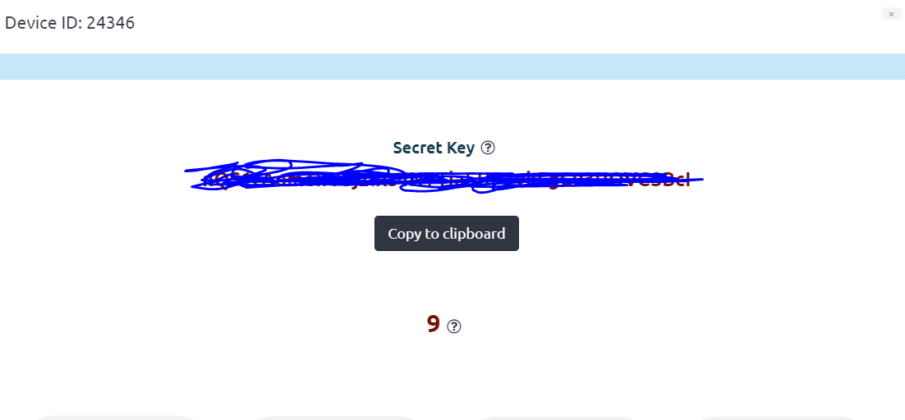

1. Once the timer is up, click on the **Open Remote Control** button.



1. **Paste** the secret key in the input text box and change username to pi. Click on **Connect**.

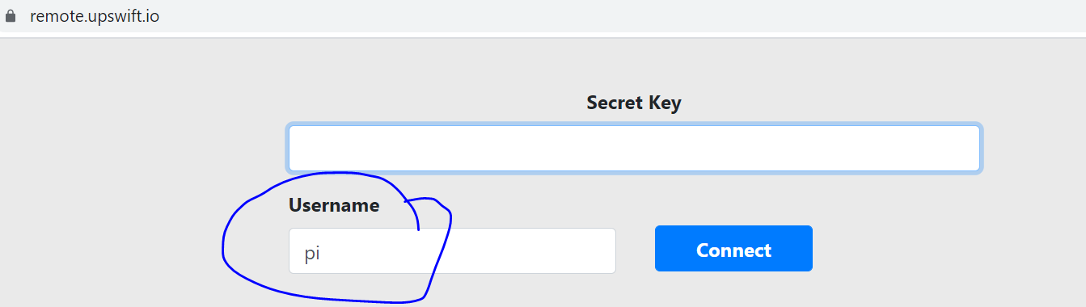

1. You will be presented with a browser based RPi terminal.

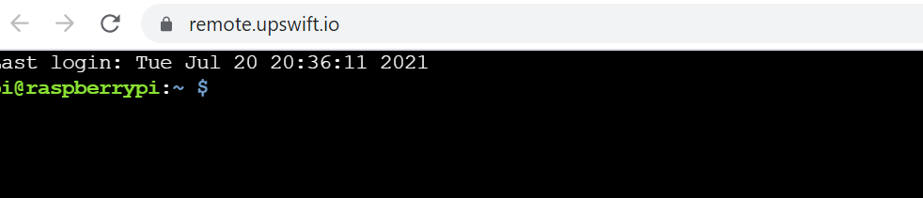

**Part B: Connect Ultrasonic and LED**

Connect the ultrasonic sensor (HC SR04) to the RPi’s GPIOs following the schematic below :

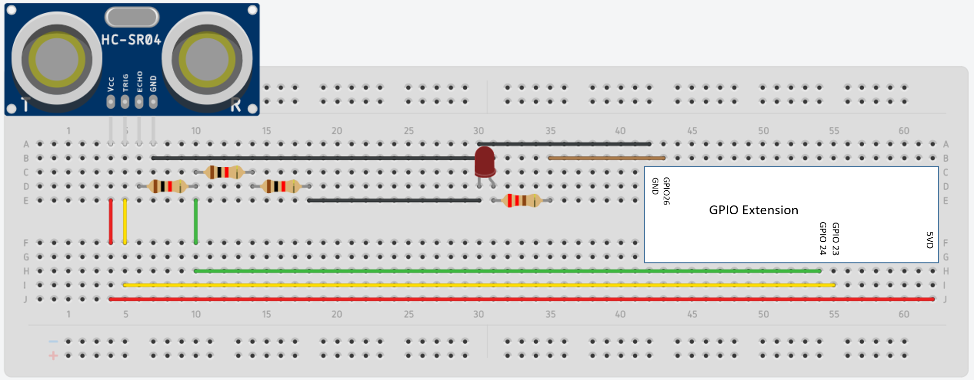

**Task 2 – Connect Ultrasonic and LED**

Perform the following steps

1. Connect Ultrasonic Vcc to GPIO 5V (Pin 1).
2. Connect Ultrasonic TRIG to GPIO 23 (Pin 16).
3. Connect Ultrasonic ECHO to 1k resistor.
4. Use two 1 k resistors in series to form a 2 k resistor (1k + 1k = 2k).
5. Connect 2k resistor to 1 k resistor and GPIO 24 (Green wire).
6. Connect 2k resistor to Ultrasonic GND and Ultrasonic GND to RPi GPIO GND.
7. For LED, connect GPIO 26 to 220 ohm resistor
8. Connect other end of 220 ohm resistor to Anode(+) of LED
9. Connect Cathode(-) of LED to GND

**Part C: Execute program to get distance data and LED feedback**

The RPi will send a trigger signal on GPIO 23. The ultrasonic sensor then sends a wave and measures the echo from any object present in front of it, if any. This echo will be sent as pulses to the GPIO 24 and the program will measure the time difference between the sending wave and receiving wave and calculate the distance.

The LED will be used to indicate if an object has appeared within 20 cm. It will light up when an **object is < 20 cm**.

**Task 3 – Execute program to get distance and**

1. Run **sudo nano job6.py.**
2. Copy the code found at <https://github.com/Prakashash18/iot-fundamentals/blob/main/job6.py>
3. Paste it into the nano editor by right clicking and pasting.

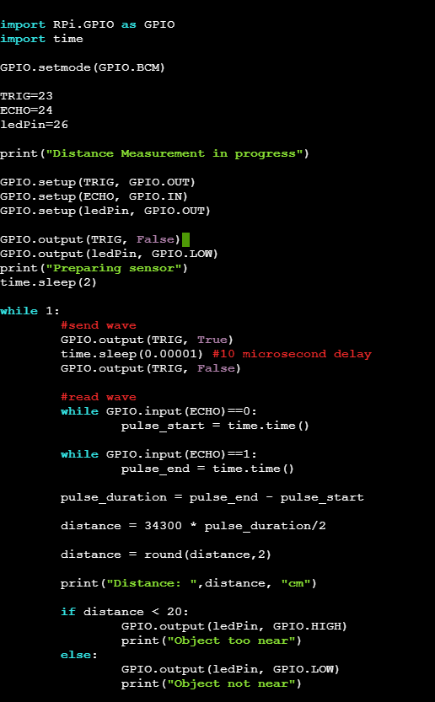

1. [Keyboard] Press CTRL + X to save your work. You will be prompted with the following message.

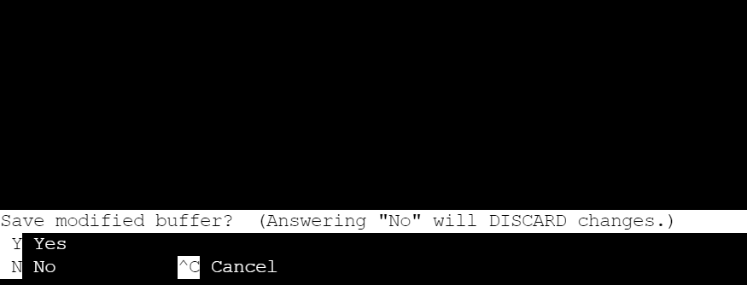

1. [Keyboard] Press **y** for yes and hit **Enter**
2. On the terminal, run **sudo python3 job6.py** to execute the code. Note that we are using python version 3.
3. You should see the distance readings and the LED lighting up when an object is < 20cm from the ultrasonic sensor. Video below :

<https://youtu.be/_o0gpAnmJ8o>

**Task 4 – Work Challenge**

You are working at AB Robotics Pte Ltd as a technician. You are part of the team monitoring the industrial robots. The current system only provides the distance and has one LED to indicate if an object is < 20cm near.

The robot is supposed to light up another LED and the robot should say **“Object not too near”**.

You are asked to **edit the program and circuit in Task 3 such that one more LED is included.**

**\*Hint, you need to**

1. Wire up one more LED with a resistor to a GPIO of choice
2. Edit the code to set up the GPIO chosen as output and include the code to turn on the LED when object >= 20cm and turn off when object < 20cm.

**Video example below:**

<https://youtu.be/AWMtlJGp1xk>

**Questions**

1. Which line in the code shows the GPIO library being imported ?



1. What is the command used to run a python script ?



1. What does sudo stand for ?

